Alphar Builders
PROPOSAL
ST1O528105
THEORENCE KOMANA
8-9-2026

Contents
Overview 1
Mission 1
Vision 1
Target Audience 1
Website goals and objectives 1
Key performance indicators 1
Current problem 2
Proposed Website features and functionality 2
Design and user experience 2
Typography 3
Technical requirements 3
Software 3
Programming languages 3
Timeline and milestones 3
Budget 4
Wireframe 5

Alpha Builders

Overview
Alpha builders is a construction and renovation company serving residential and small commercial customers, the company does a range of thing from renovations, extensions, maintenance, painting to property improvement services. The company was founded by Johnson Brown who has over 4 years of experience in the field, and alpha builders was built from the ground up in 2020 and is based in Limpopo.

Mission
The alpha builder’s mission is to build affordable, reliable and high-quality buildings and to provide high-quality construction services at the same time maintaining professional standards, customer service and a safe working environment

Vision
The vision is to become a trusted construction and renovation company recognised for quality workmanship, dependable service and innovative building solutions.

Target Audience
- Homeowners
- Landlord
- Property owners

Website goals and objectives
The main goal for the Alpha builder’s website is to make a professional online presence that will allow potential customers to learn about the company, view its services and the projects the company have done and to contact the business. As in the moment the business has no online presence and the only way to get in touch with the company is though phone calls.
Objectives
The website will be able to
- Introduce the company and its services to customers
- Give information on the company history and mission and vision
- Showcase the companies work
- Generate customers enquiries
- Make it more efficient to contact the company

Key performance indicators
KPI | Target
Website visitors | Increase monthly visitors
Enquiries | Generate construction enquiries
Contact submissions | Receive customer contact requests
Service-page visits | Increase visits to service information
Gallery engagement | Increase project-gallery views
Navigation success | Users can access all pages without broken links
Mobile usability | Website works correctly on mobile devices
Page performance | Pages load efficiently
Customer engagement | Increase enquiries generated through the website

Current problem
Alpha Buillders has no website

Proposed Website features and functionality
Home page with an introduction to the company
About us page with a brief history about the company
Services page that out lays all the services the company offers
Enquiry page with FQAs and ways to contact the company
Contact page with all the ways to contact the company

Design and user experience
Proposed brand- Alpar
Colour scheme
Green and white
User Experience
The website should:
- Be easy to navigate.
- Use clear navigation labels.
- Have consistent navigation on every page.
- Use readable text.
- Provide clear calls to action.
- Avoid unnecessary clutter.
- Make contact information easy to find.
- Provide obvious enquiry buttons.

Typography
- Aptos for general project documentation.
- A professional sans-serif font for the website.
- Large bold headings.
- Medium-sized subheadings.
- Clear body text.

Technical requirements

Software
Visual studio code
Web browser
GitHub

Programming languages
Html5
CSS
JavaScript
Domain
www.alphaconstruction.co.za
hosting

Timeline and milestones
Week | Activity | Deliverable
Week 1 | Select organisations | Two organisation options
Week 1 | Research | Organisation information
Week 2 | Write proposals | Two proposals
Week 2 | Lecturer approval | Approved organisation
Week 2 | Content research | Text/images/assets
Week 3 | Sitemap | Website structure
Week 3 | Wireframes | Low-fidelity designs
Week 3 | Folder structure | Project directory
Week 4 | HTML development | Five HTML pages
Week 4 | Navigation | Working page links
Week 4 | Testing | Browser testing
Week 5 | GitHub | Repository and commits

Budget
Website planning R1500
HTML DEVELOPMENT R3000
CSS R3000
JavaScript R3500
Domain registration R200
Hosting R1200 per yer
Maintance R1500

Wireframe

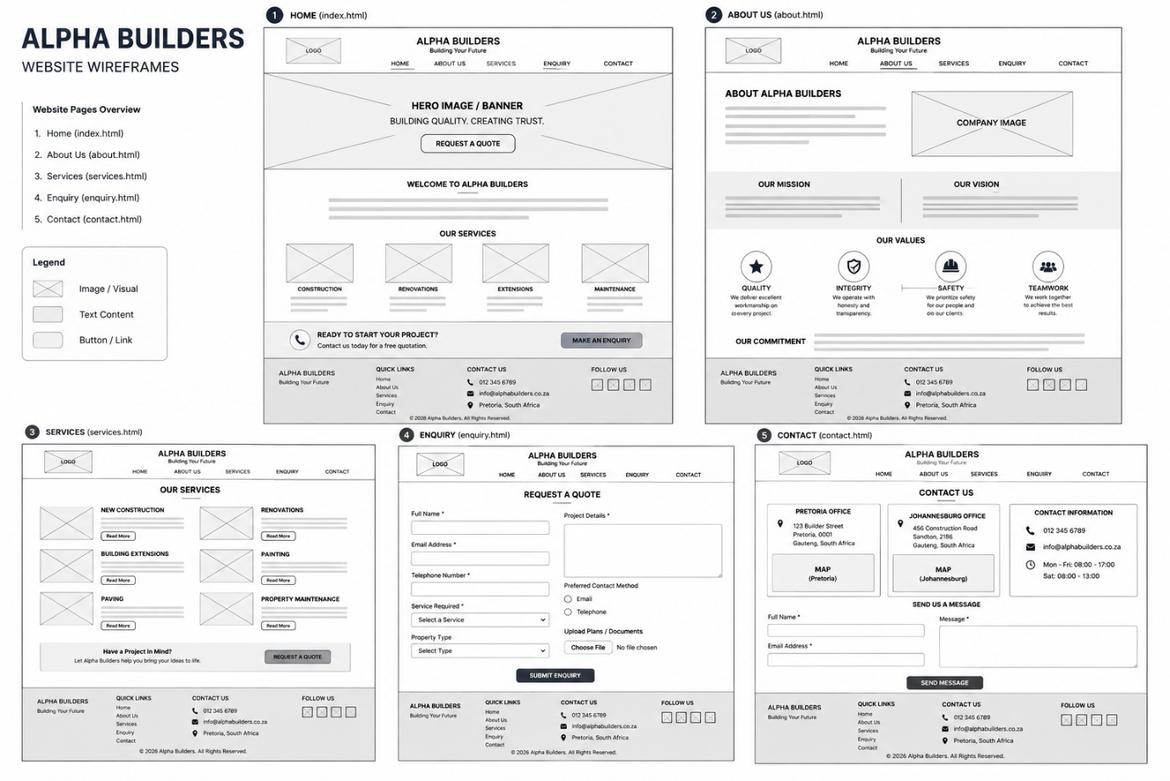

Bibliography
AI, o., 2025. chatGPT. [Online]
Available at: https://chat.openai.com
BlackBerry QNX, 2023. BlackBerry. [Online]
Available at: https://blackberry.qnx.com/en/ultimate-guides/what-is-real-time-operating-system/
[Accessed 6 sep 2025].
Business insider, 2022. business insider. [Online]
Available at: https://www.businessinsider.com
Chat gpt, n.d. chat gpt. [Online]
Available at: https://chatgpt.com/c/68a5aac2-8b18-8322-9c90-dc70680c1ec9
[Accessed 12 AUG 2025].
IT Web, 2024. ITWeb. [Online]
Available at: https://www.itweb.co.za/article/capitec-uses-bi-ai-to-offer-safer-banking-experience/8OKdWMDXjQBMbznQ
K&W Construction, 2025. K&W Construction. [Online]
Available at: https://www.kwconstruction.co.za/project-gallery/
[Accessed 01 Aug 2025].

